7th grade Advanced Math USA T7 5 Preview
Name: _____________________

- If two figures are similar AND congruent, which of the following transformations must NOT have occurred?
- Dilation
- Reflection
- Rotation
- Translation

- Two lines, a and b, are parallel. If both of the lines are rotated 180° in the same direction and then translated to the left by the same number of units, which statement about the lines resulting from these transformations is true?
- They will be the same line.
- They will be parallel.
- They will be perpendicular.
- They will be at the same location they started in.

- Select all the transformations that maintain a shape’s congruency.
- A translation 4 units down
- A reflection across the y-axis
- A rotation of 90° clockwise about the origin
- A rotation of 270° about the origin
- A dilation with a scale factor of 3
- A dilation with a scale factor of 1
- A reflection across the x-axis and then a translation four units left
- A dilation with a scale factor of 2 and then a dilation with a scale factor of $\frac{1}{2}$
- A translation one unit right and then a dilation with a scale factor of less than 1
- A rotation of 180° about the origin and then a dilation with a scale factor greater than 1

- Triangle ABC is rotated 45° counterclockwise about vertex C to obtain triangle XYZ. If the m<ACB is 70°, what is the m<XZY?
- 110°
- 10°
- 45°
- 70°

- Refer to the figure below and match the angle with the correct measurement in degrees.
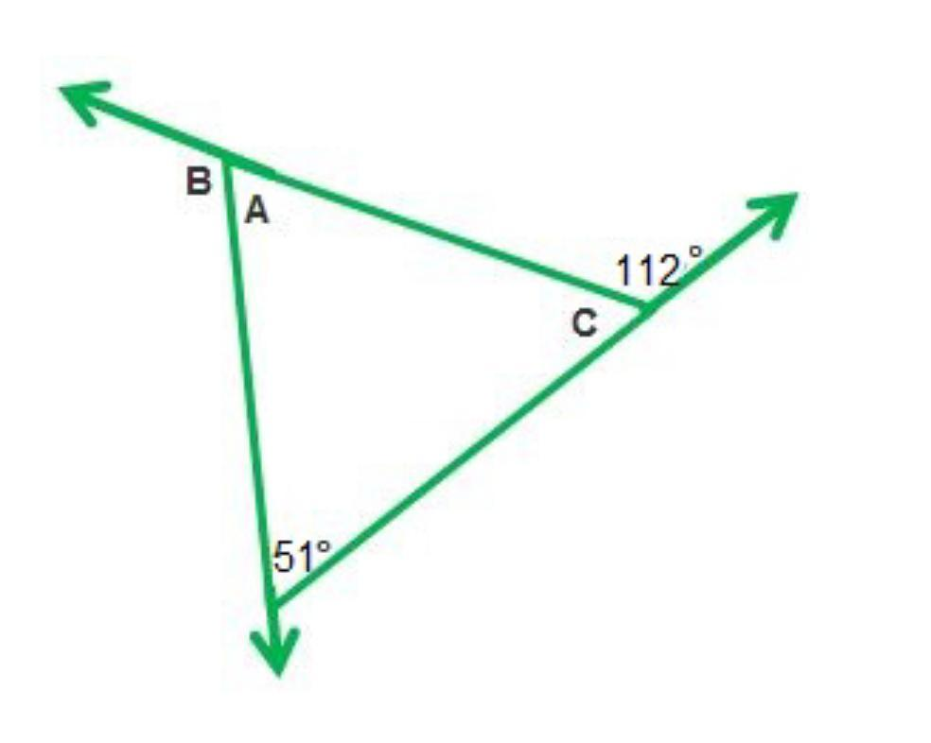
D
 | 61° | 68° | 119° | 129°
<A

<B

<C

<D

- Tomas is dilating rectangles. Rectangle ABCD was dilated to create rectangle WXYZ. Rectangle ABCD has an area of 16 mm² and rectangle WXYZ has an area of 64 mm². Which of the following conclusions can Tomas make?

- Tomas knows that 64 is 4 times larger than 16, therefore he thinks the scale factor is 4.

- Tomas knows that 16 times 4 is 64, therefore he thinks the dimensions were each multiplied by 4.

- Tomas knows that 16 multiplied by 4 is 64. He also knows that the area is found by multiplying the length and the width, therefore he thinks the scale factor is 16 because 4 x 4 is 16.

- Tomas knows that the area of rectangles is found by multiplying the length by the width, therefore he thinks both the length and the width were doubled so that the area of WXYZ would be 4 times larger.

- Lines a and b are parallel. The measure of angle 3 is 110°.
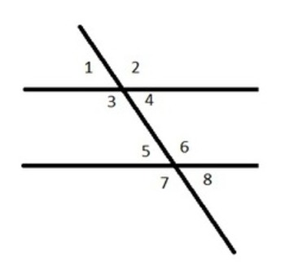
b
a
What is the measure of angle 8?

- 20°
- 70°
- 90°
- 110°

- Triangle ABC is shown on the coordinate plane below.
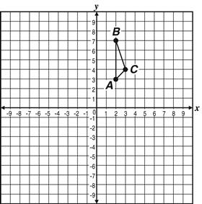
m

Match the coordinates of the vertices of the image of ΔABC after a reflection across line m.
 | (8, 7) | (8, 3) | (7, 4)
A’

B’

C’

- What is the measure of <ECD, in degrees, in the figure shown?
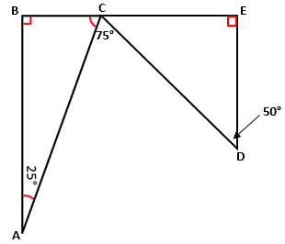

- 50°
- 65°
- 75°
- 140°

- Triangle QAG is similar to triangle XYZ.
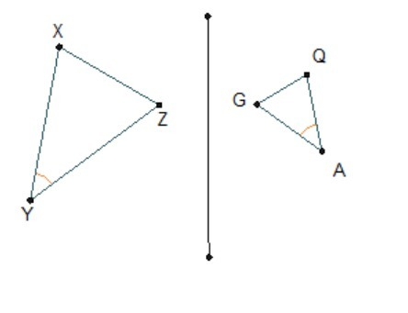
N
Mm
Which transformations could transform ΔQAG into ΔXYZ to show that they are similar?

- Reflect across line MN, then dilate with a scale factor greater than 1.
- Reflect across line MN, then dilate with a scale factor less than 1.
- Translate left across line MN, then dilate with a scale factor greater than 1.
- Translate right across line MN, then dilate with scale factor less than 1.

- Which diagram choice represents a dilation by a scale factor of $\frac{1}{2}$ from the rectangle’s center?
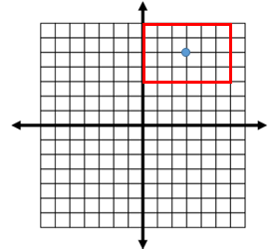
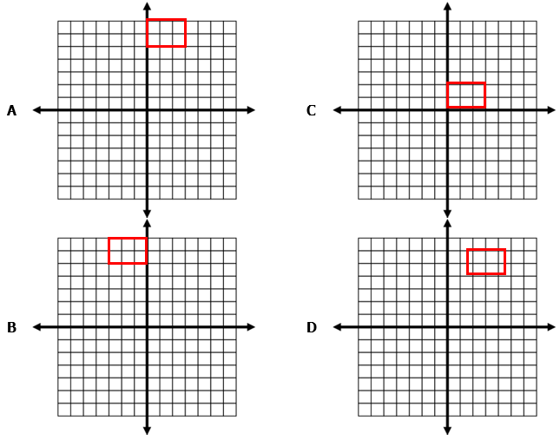

- Triangle XYZ is a scalene triangle.
m<X = 6a°
m<Y = (4a -5)°
m<Z = 45°

What are the 3 angle measures?
- 45°, 51°, 84°
- 14°, 56°, 84°
- 51°, 56°, 73°
- 14°, 45°, 121°
- Triangle LMN is translated 3 units to the left on a coordinate plane to form triangle XYZ. The measure of segment LM = 8 units, the measure if segment MN is 6 units, the measure of LN is 4 units, and the measure of <N is 80°.

Which of the following could be a corresponding measure of triangle XYZ?

- Segment XY is 6 units
- Segment YZ is 8 units
- m<XYZ is 80°
- m<Z is 80°

- Select all of the diagrams that show m || n.

A | 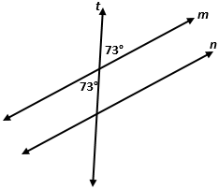 |  | B | 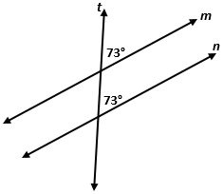
C | 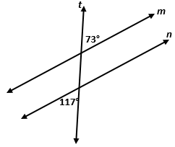 |  | D | 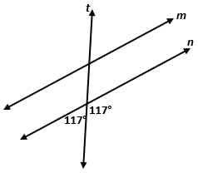
E | 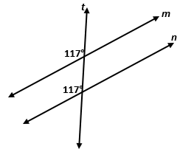 |  | F | 